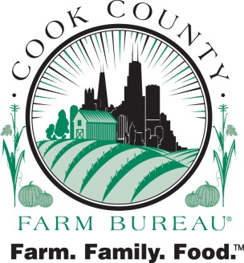
6438 Joliet Rd
Countryside IL 60525

October 18, 2017

To: Horseman’s Council of Illinois
From: Bona Heinsohn, Cook County Farm Bureau®
Reason: Support of the Carriage Industry in Chicago

Carriage horses are an iconic part of Chicago. For many families, carriage horses and their drivers may be only contact they have with agriculture and livestock. Through scrupulous training and handling, carriage horses are comfortable in loud, urban areas.

Chicago’s carriage horses are among the most regulated horses in the country in an effort to ensure that they are well cared for in terms of stabling, access to appropriate food and water, grooming, horseshoeing, veterinary care and working conditions. Per existing regulations, horse drawn carriages cannot operate at ambient temperatures below 15 or above 90 degrees. Additionally, Chicago carriage horses enjoy a workday of six hours or less, with a 15-minute rest every hour. Regulations require tight monitoring of horse health and welfare and Chicago’s current carriage operators have a spotless record of animal husbandry.

According to the Antique Horse Carriage organizations, Chicago pedestrians have never been injured or hurt by a horse or carriage.

Cook County Farm Bureau® policy supports the growth and enhancement of animal agriculture in Cook County (Policy #1300 Animal Agriculture). The much beloved, carriage horse industry is a vital connection for many urban families to Cook County and Illinois agriculture.

As the county’s largest general farm organization, Cook County Farm Bureau® is dedicated to bridging the gap between farmers and urban consumers. Through education programs targeting youth and their parents and programs designed to connect farmers with potential consumers, Farm Bureau members are actively engaging in conversations about food and the shared values between farmers and consumers.

If you have any questions regarding this issue or would like any additional information, please do not hesitate to contact me at (708) 354-3276 or via email at bona@cookcfb.org.

COOK COUNTY FARM BUREAU®
To serve all our members of the Cook County Farm Bureau ® with meaningful and beneficial programs that reflect our agricultural heritage.

