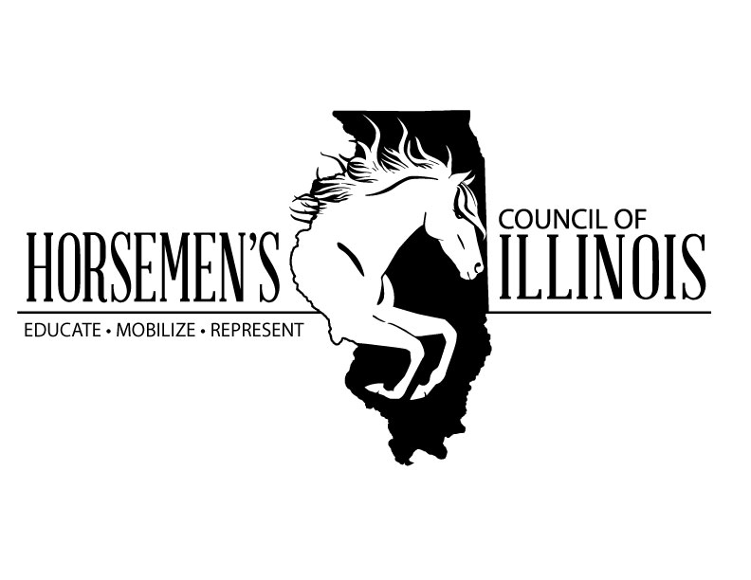
HORSEMEN’S COUNCIL OF ILLINOIS SUPPORTS THE HORSE DRAWN CARRIAGE INDUSTRY IN THE CITY OF CHICAGO

The Horsemen’s Council of Illinois (HCI) strongly supports the horse drawn carriage industry in the city of Chicago. The carriage horses of Chicago are an iconic symbol of the city and reflect its cultural heritage. These horses serve as beautiful ambassadors to Illinois’ agricultural power and a last remaining testament to the reality that horses and horsepower literally built the city of Chicago. They provide economic benefits through tourism and tax revenues, provide employment for drivers, caregivers, farriers, veterinarians, harness and carriage artisans, agricultural commodities in the form of forage, grain and bedding, vehicles and fuel and much more.

The carriage horses of Chicago serve as ambassadors not only to the past, but to the present and future of Illinois. Surrounded by a city of steel and machines, these horses may be a city dweller’s only contact with a large farm animal. Seeing, touching, smelling these animals may be a key to connecting with and understanding agriculture. Horses remind us that Illinois feeds the world and agriculture is how Illinois thrives. Horse drawn carriages provide riders with an opportunity to slow their pace of life and enjoy a moment of peace in a sometimes-chaotic world.

Horses have always operated in crowded conditions, noise and even chaos. Horses have served courageously in war and still work to keep the peace in most cities in America, including Chicago. Horses are happiest when they have a job to do for which they are well suited and trained. Indeed the carriage horses in Chicago have been well trained and conditioned to their environment and are calm and undisturbed by the noise and bustle of both vehicular and pedestrian traffic. Proof of this is their perfect 37-year record with not a single serious accident.

Chicago’s carriage horses are among the most regulated horses in the country to insure that they are well cared for in terms of stabling, access to appropriate food and water, grooming, horseshoeing, veterinary care and working conditions. For example, horse drawn carriages cannot operate at ambient temperatures below 15 or above 90 degrees. The work of a Chicago carriage horse is not taxing; they work at a walk, receive regular rest, water and care during their working day. Regulations require tight monitoring of horse health and welfare and Chicago’s current carriage operators have a spotless record of husbandry.

Horsemen’s Council of Illinois sent a delegate to all of Chicago’s horse drawn carriage operators’ stables to review animal health, standards of care, handling and general welfare. It is the opinion of the HCI that the Chicago carriage industry is an excellent example of responsible horse husbandry. The stables were clean and well maintained, the horses had clean water and were well fed, their hooves and health were routinely assessed and attended to, and their attitude was calm, well-adjusted to their surroundings and they were well trained for their assigned tasks with no signs of mental or physical stress. In short, the horses were happy. We found the owners to be loving and devoted to the welfare of their animals. They represent an exemplary model for animal welfare in our fair city.

The Horsemen’s Council of Illinois represents the multi-billion dollar Illinois horse industry in its entirety, including all breeds of horses and disciplines of horsemanship within the great state of Illinois.

